Accommodation of Revised Awards discussion

## **Goal:**

## On conceptual level discuss the options for accommodation of revised awards. Selected option will affect database structure.

## **Agenda:**

* Visuals for discussion of options
* Overall business questions
* If possible => Selection of the option

**Help materials portion:**

* If option is selected and time permits => questions specific to a selected option
* If needed => More detailed description of the options; pros and cons for each options from CBIIT point of view
* If needed => Reference to existing rules (how the system works), if needed

NOTE: Proposed options are based on the information that:

* Grant can have only 1 AWARD action (not in Closed status)
* Grant can have multiple REVISION actions
* The same set of question (questionnaire) will be used for ALL revision actions for ALL type/mechanisms
* Only GMS have revision questionnaire

Please confirm. - Confirmed

## Visuals for discussion

**Option 1: Add revision checklist in GPMATS (similar as Triage Questionnaire)**

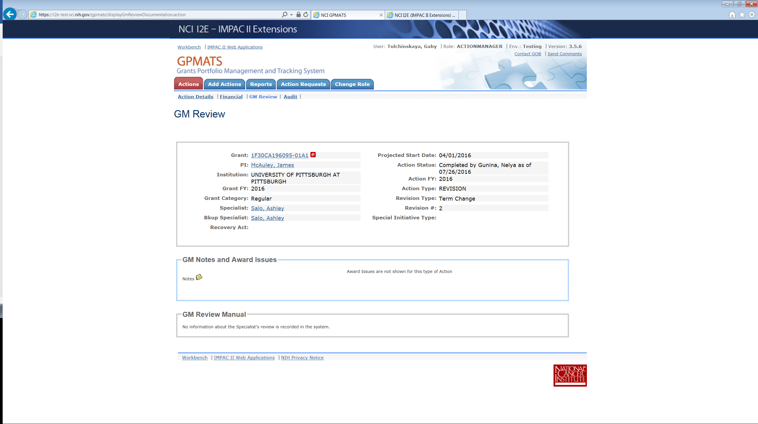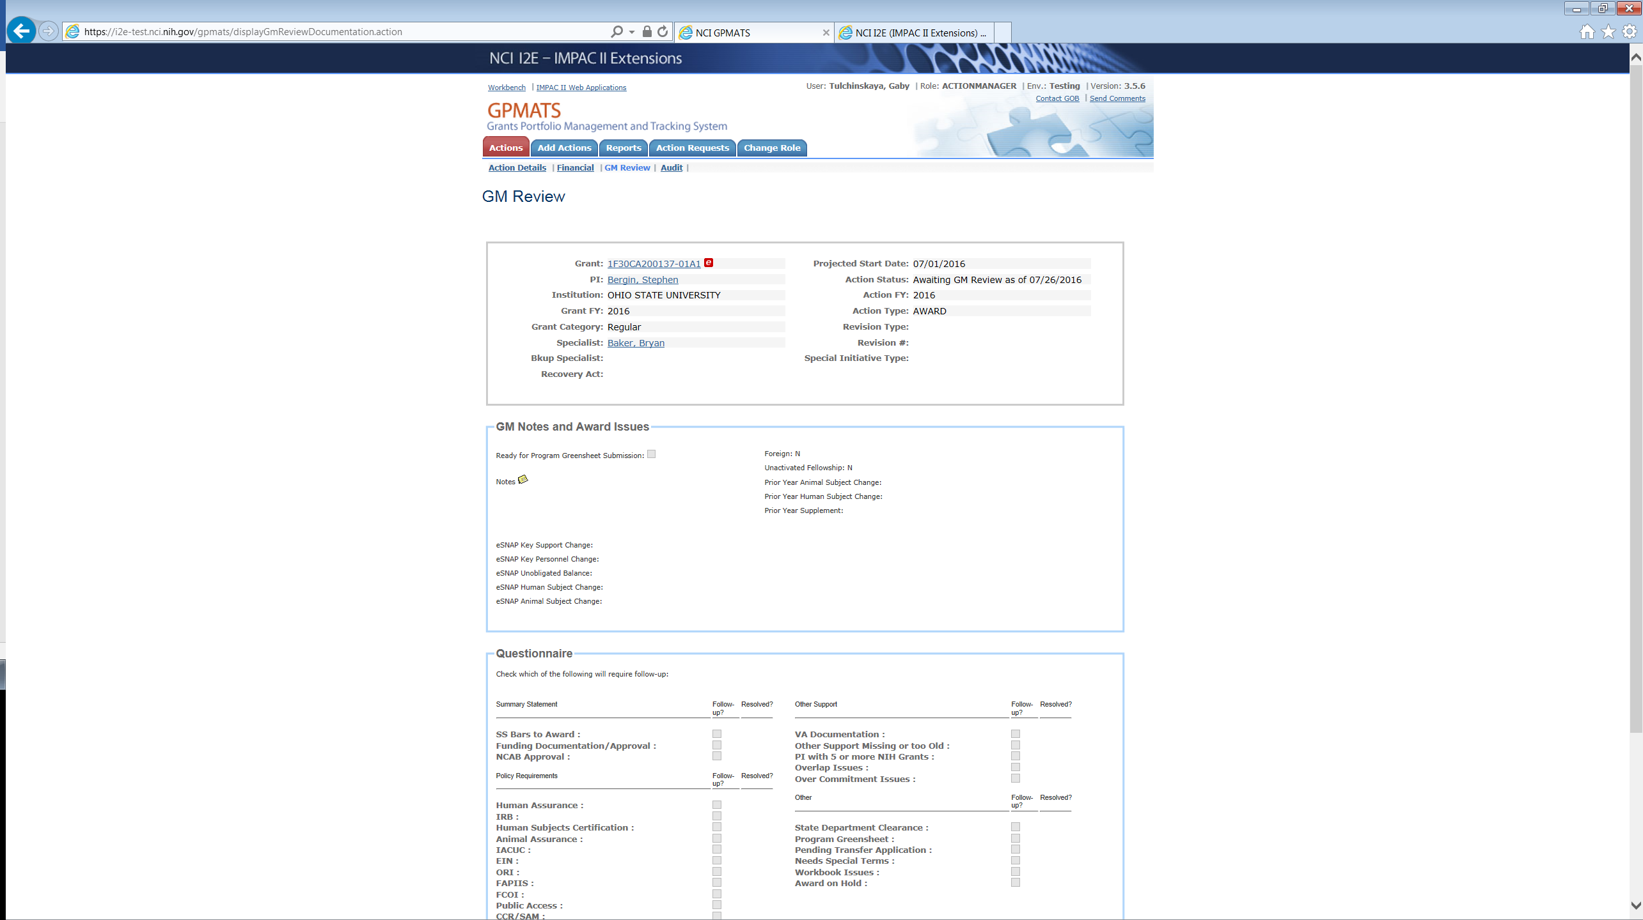

**Option 2: Allow additional GMS greensheet(s) in GreenSheets for revision; different form type will be used for AWARD and REVISION actions**

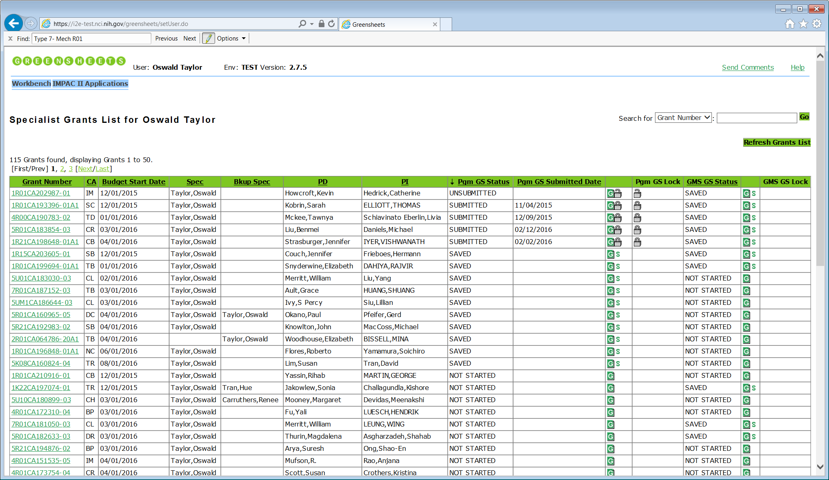

|  |  |  |  |  |  |  |  |  |  |  |  |  |  |  |  |
| --- | --- | --- | --- | --- | --- | --- | --- | --- | --- | --- | --- | --- | --- | --- | --- |
| **Grant Number** | **CA** | **Budget Start Date** | **Spec** | **Bkup Spec** | **PD** | **PI** | **GPMATS Action Type** | **OGA Award Release date** | **Pgm GS Status** | **Pgm GS Submitted date** |  | **Pgm GS Lock** | **GMS GS Status** |  | **GMS GS Lock** |
| 1R01CA202987-01 | IM | 12/01/2016 | Taylor, Oswald | Clark, Patty | Liu, Grace | Tran, David | Award | 5/29/2015 | FROZEN | 11/04/2016 |  |  | FROZEN |  |  |
| Revision/ Term change | 2/03/2016 |  |  |  |  | FROZEN |  |  |
| Revision/ Co-fund |  |  |  |  |  | SAVED |  |  |
| 5R01CA123456-04 | CE | 12/01/2016 | Clark, Patty | Perry, Carol | Hubbard, Leah | Wu, Tzyy | Award |  | SUBMITTED | 11/04/2016 |  |  | SAVED |  |  |
| 5R01CA077476-03A1 | CB | 12/01/2016 | Clark, Patty |  | Hubbard, Leah | Woo, Tong | Award | 2/03/2016 | FROZEN | 11/04/2016 |  |  | FROZEN |  |  |
| Revision/ Co-fund |  |  |  |  |  | SAVED |  |  |

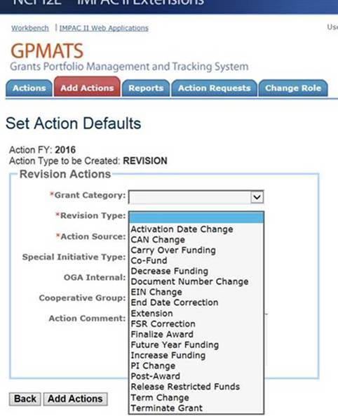

### **Questions:**

### **Overall (applicable to both options)**

* How often do you expect changing revision questionnaire? - OGA answer: rare
* Do you need attachments- OGA answer: yes, comments- OGA answer: yes and conditional questions- OGA answer: no for revision questionnaire? -
* Do you need to change revision questionnaire via GPMATS change request or have a full control via FormBuilder? - OGA answer: Full control via FormBuilder is needed
* Should revision questionnaire be used for ad-hoc reporting? - OGA answer: no, revision questionnaire would NOT be used for ad-hoc reporting
* Do you need versioning for revision questionnaire? - OGA answer: no, versioning is not needed. CBIIT comment: the system wouldn’t prevent versioning, it simply wouldn’t be used
* If revision questionnaire will be in GPMATS is there a need for submission? If submission is needed, do you need validations in GPMATS that revision questionnaire is submitted before revisions action is completed? – OGA answer: n/a
* What is a triggering event when the questionnaire for the revision should be displayed (as soon as Revision action - yes is created or should we wait for a certain status or any other event)? - OGA answer: access to revision questionnaire should be provided in GPMATS as soon as Revision action is created.
* Can revision action exist without AWARD action? – discussion postponed until we will discuss actual UI in GreenSheets system. AWARD action always exists, but not necessarily in the same FY. FY for the grant and FY(s) for revision(s) could be different. OGA will evaluate a value of displaying records for revision greensheets with award greensheets on the grant hit list (see mockup).

### **Additional questions for option 1:**

1. Will there be any changes to the current GPMATS workflow, if questionnaire for the “Revision” actions will be part of GPMATS? – n/a
2. Will Revision Questionnaire apply only to NCI Grant applications? - OGA answer: Yes
3. Will the Revision Questionnaire apply to all the Revision Types?  - OGA answer: Yes
4. Similar to the Award GM Triage questionnaire, is there a need to tag a checklist item for follow-up and resolve it before completing it or sending it for additional GM Review? - N/A since option 2 has been chosen
5. If Revision Questionnaire will be part of Greensheets, will the status of the Greensheet prevent the action from being Completed? OGA answer: no
6. Can more than one revision action have the same revision type selected? – yes If no, can we add a validation in GPMATS that the same Revision Type cannot be selected if one exists already and has NOT been Cancelled? – n/a

### **Additional questions for option 2:**

* How should we indicate revised awards for the same grants on the screen (display revision type or any other field)? – OGA will evaluate the need to display revision awards on the hit list screen, maybe only AWARD actions will be displayed. Link from GPMATS (“G” icon) will take specialist directly to the form; “G” icon should be always displayed for all revision types, unless revision action is closed or cancelled.
* Should greensheets record display any additional information about revision action (e.g. OGA award release date)? – discussion is postponed until UI conversation
* Should PD screen indicate existence of revisions? Currently PD sees specialist greensheet status, but don’t have ability to view actual greensheet – OGA answer: no, PG screen should not indicate revisions, specialist will reach out to PD on as-needed basis, outside of GreenSheets system
* What is a triggering event when the greensheet for the next revision action should be frozen (“Closed” status on this revision action)? - OGA answer: yes, when revision action is closed.
* Cancelled action after save/submission - > delete greenshets from eGrants and GS/GPMATS.
* Can several revision greensheets for the same grant be editable at the same time? - OGA answer: yes, it’s possible. We need a separate instance of greensheet for each revision action. In case of multiple revision actions, we need a warning in GPMATS. Or do we have to have prior greensheet frozen before the user can work with the next revision greensheet? - no

**Decisions summary:**

1. Option 2 has been selected. GreenSheets system will be used for accommodation of revised awards. Different form types must be implemented in FormBuilder for the same grant for AWARD action and for Revision action. Same revision form will be used for ALL type/mechanisms. Revision form will be deployed/promoted from FormBuilder to Greensheets. In Greensheets this form will be displayed to specialist only.
2. Multiple Revision actions can exist for the same grant simultaneously. Each Revision action will have a **separate instance** of greensheet (revision type)
3. In case of multiple revision actions, we need a warning in GPMATS
4. Each instance of revision greensheet will follow existing process (NOT STARTED => SAVED => SUBMITTED => FROZEN when Revision action is in “Closed status; and can be un-submitted before freezing)
5. When revision greensheet is submitted, it should become a part of official file document (displayed in eGRANTS).
6. When Revision action is in “Closed” status in GPMATS, associated revision greensheet will have FROZEN status.
7. When Revision action is in “Cancelled” status in GPMATS, associated revision greensheet will be deleted from eGrants/GreenSheets/GPMATS
8. When user is closing revision action is GPMATS, the system should NOT validate that revision greensheet is submitted.
9. “G” icon(s) will be displayed in GPMATS for each Revision action until this action is closed or cancelled. When user clicked “G” icon, user will be taken to an actual specialist form of revision type
10. “G” icon(s) will be displayed in GPMATS for each Revision action regardless of revision type, no warnings about multiple revision actions is needed. If specialist completes/submits revision greensheet for each action for the same grant, extra revision greensheets will be deleted on cancellation.
11. OGA will create a following business process in case of multiple Revision actions for the same grant:
    1. When revision is awarded, one revision action must be closed.
    2. All other associated revision actions will be cancelled that will trigger deletion of extra instances of greensheets
    3. This process is NOT going to be enforced by the system; this is users’ responsibility
12. Any specialist (not only assigned) can navigate to GreenSheets and complete/submit the form

## **Description of the options; pros and cons**

|  |  |  |  |
| --- | --- | --- | --- |
| **#** | **Options** | **Pros** | **Cons** |
| 1 | **Add revision questionnaire in GPMATS (similar as Triage Questionnaire).**   * Questionnaire will be hardcoded for revision * Some revisions don’t need a questionnaire, will have to implement a logic how to determine such revisions * When GPMATS system will determine that submission of revision a questionnaire is needed, the system will display a questionnaire on GM Review page * Currently, there is no concept of submission of the questionnaire in GPMATS. As a result, it is editable until Revision action is in Closed status. Do we need any changes? * Should GPMATS be modified to add validation on completion/submission of the revision questionnaire before completing Revision action? * Currently, when questions are added/deleted from AWARD questionnaire, the new questionnaire is displayed only for newly created actions. Should it be changed? | * Simplicity for a user * Doesn’t affect FormBuilder and GreenSheets system * No need to navigate to GreenSheets | * Questionnaire is hardcoded, there is no process of creation/review/deploying new questionnaire. * Lack of visual, “at a glance” representation of all questionnaires for a grant * Inconsistent business flow (for AWARD actions user have to go to GreenSheets and for REVISION stay in GPMATS) * If any of the changes in the blue are needed – extra work |
| 2 | **Allow additional revision type GMS greensheet(s) in GreenSheets; different form type will be used for AWARD and REVISION action**:   * Users will create revision template (revision form) in FormBuilder and promote it to Greensheets * Greensheets system will allow grants with revision action to be visible. If the system finds revision action the **revision type** of greensheet will be displayed. * Some revisions don’t need a questionnaire, will have to implement a logic how to determine such revisions * Direct link from GPMATS to Greensheets will be provided. It will help with easy completion/submission of revision greensheets * Should GPMATS be modified to add validation on completion/submission of the revision questionnaire before completing Revision action? | * Re-use of functionality for creation and managing a form in Form/Builder * Re-use of form versioning * Re-use of existing logic/statuses for completion and submission of greensheets * Consistent workflow * Visual, “at a glance” representation of all questionnaires for a grant | * Additional modifications to FormBuilder to allow the user create and deploy different types of forms (for AWARD and for REVISION). * Additional modifications to GreenSheets (to allow grants with revision to be visible) |

## Existing rules (how the system works currently)



If grant is NOT in GPMATS (no actions at all):

* Specialist view => grant is not displayed in GreenSheets specialist view
* Program view => grant is displayed in GreenSheets program view, greensheet can be saved, but not submitted

If grant is in GPMATS, the system checks if it has REVISION action.

* Grants with REVISION action are NOT displayed in Greensheets system at all.
* Grants with AWARD action are displayed in both GMS and PD views, unless status of AWARD action is Cancelled. PD can SUBMIT greensheet with AWARD action.

NOTE: there are some additional rules when grant is not displayed in GreenSheets, but they are not relative for the purpose of this discussion.

